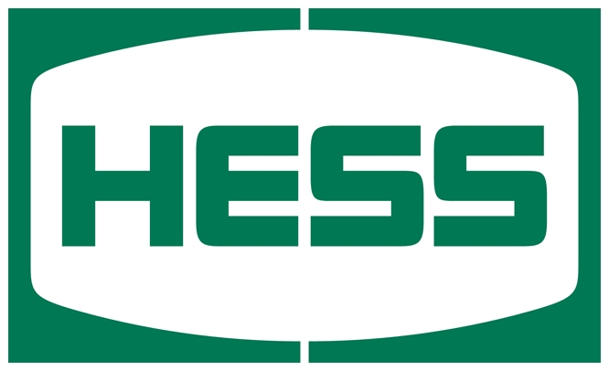

**HESS Corporation**

**GHG Validation Portal User Manual**

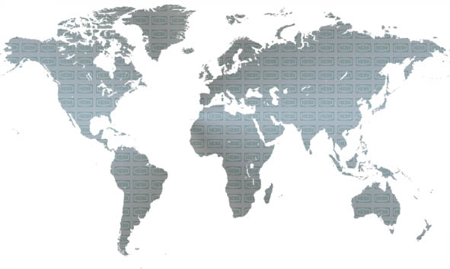

Table of Contents

1. Introduction 3

1.1. Purpose of this document 3

2. General Overview 3

2.1. Purpose of Validation Portal 3

2.2. Page Layout 3

3. Review and Approve Monthly Data 5

3.1. Standard Approval Page 5

3.2. Vessel Approval Page 5

3.3. Workflow Page 5

4. Admin 6

4.1. Facility Admin 6

4.1.1. Create new facilities 6

4.1.2. Manage Facilities 6

4.1.3. Manage Facility Owner 6

4.2. Asset Admin 7

4.2.1. Create new assets 7

4.2.2. Manage Assets 7

5. Support 7

# Introduction

# Purpose of this document

This document is aimed at:

* Providing a general overview of the GHG Validation Portal & Navigation
* How to review and approve monthly data
* How to manage the creation of new facilities and assets
* How to assign users to new facilities
* Who to contact for support related questions or user issues

# General Overview

# Purpose of Validation Portal

The purpose of the EH&S Data warehouse is to provide a central repository for the operational data needed for calculating emissions and criteria pollutants in ENVIANCE. The following are examples of operational data that is tracked in the data warehouse:

* Hours of Operation for Equipment
* Diesel / Electric Usage
* Production Volume Data
* Flare Usage

This data can come from a system generated interface or be manually input by the user each month.

# Page Layout

The GHG Validation portal user interface is separated into two components: The Search Grid and the Details Grid

**Search Grid**



|  |  |  |
| --- | --- | --- |
| **Name of Field** | **Purpose** | **Example** |
| Entity | Parent level grouping. If selected the result set would show data for all facilities assigned to it. | North Dakota |
| Facility | Facility level data | Tioga Gas Plant |
| Validation Period | Period for which the data is being validated | March 2013 |
| Source Category | List of source categories based on the selected facility. If entity is selected all source categories are displayed | Flaring |
| Asset Name | List of assets at the selected facility | South Flare |
| Asset Type | List of asset type for the selected asset | Flare Stack |
| Data Source | List of all data sources | Flowcal |
| Show Data | List of filters that can be used to refine the resultset | Validated |

**Toolbar**



|  |  |
| --- | --- |
| **Name of Field** | **Purpose** |
|  | By default the record count to be displayed is limited to 25 records. If more than 25 records are returned paging will be used in the resultset. A user can click the down arrow to show all records on one page or the up arrow to reset back to 25. |
|  | To edit data click the pencil. To cancel edits click the pencil with red line through it. |
|  | Used in edit mode to reset the page back to its last saved state. Essentially an undo. |
|  | Will display the workflow page when clicked |
|  | Used to display the process log history to see interface status from source system |
|  | Will create a new facility or asset. Only available on the admin pages for users in the main admin group. |
|  | Will allow existing assets to be copied from a base asset. Only available on the Asset Admin page by users in the main admin group. |

**Details Grid**

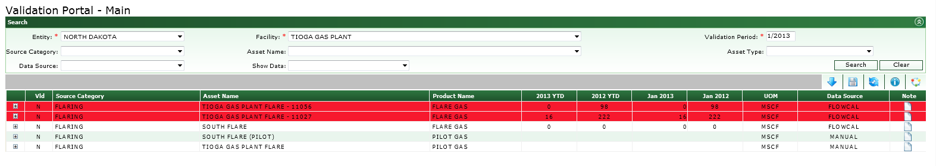

|  |  |
| --- | --- |
| **Name of Field** | **Purpose** |
| VLD | Validation Indicator. Y = Validated; N = Not Validated (Default); X= Validated but do not send to ENVIANCE; I = Record was validated but a new one has been received**.** |
| Source Category | Based on search |
| Asset Name | Based on search. Displays the name of equipment or asset being measured |
| Product Name | Product name for asset |
| YTD | Year to date totals |
| PYTD | Total year to date for same period last year |
| Current Month | Current monthly value |
| Prior Year Current Month | The value that existed for the same month last year |
| UOM | Unit of Measure |
| Datasource | Where data is sourced from for specific record |
| Note | A user can add comments or view/update existing ones by clicking the note icon. If comments are available then an  icon will appear. If no comments are available then an  icon will appear. |

# Review and Approve Monthly Data

# Standard Approval Page

The steps for reviewing and validating date are show below:

1. Go to <http://ghgemissions.ihess.com>
2. Select an Entity or Facility that you are assigned to along with a validation period and click search
   * You can add additional search criteria as needed.
3. When the search results are displayed, confirm the numbers are correct.
   * Clicking the ‘+’ sign will expand the detail row to show the monthly values for the current year.
4. Click the row you wish to validate which will highlight it in green. Then click VLD cell and select Y to approve the row.
   * If a value needs to be entered because it’s listed as a manual input, then you can do so by clicking in the cell and directly entering the value.
   * If you overwrite a system generated value, you will need to supply a reason why in the comment field.
   * A monthly value is required for any rows that you are setting to Y. This includes all the child rows that exist on summary pages such as .All North Dakota
   * A user can add comments or view/update existing ones by clicking the note icon. If comments are available then an  icon will appear. If no comments are available then an  icon will appear.
5. Click Save

**Note(s):**

1. You can set the VLD indicator for all records by setting the VLD on the first row and then clicking the VLD column header.
2. If a row is red you can click on the asset name for an explanation.
3. If a cell is yellow you can click on the value for an explanation.
4. If a cell is brown it’s because you edited a monthly value but have not yet saved your changes.

# Vessel Approval Page

The vessel approval page is used for to validate data on imports via Vessels. The steps to reviewing and approving this data are shown below:

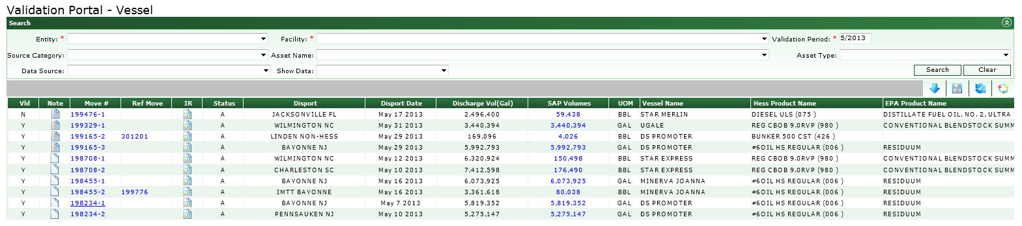

|  |  |
| --- | --- |
| **Name of Field** | **Purpose** |
| VLD | Validation Indicator. Y = Validated; N = Not Validated (Default); X= Validated but do not send to ENVIANCE; I = Record was validated but a new one has been received**.** |
| Note | A user can add comments or view/update existing ones by clicking the note icon. If comments are available then an  icon will appear. If no comments are available then an  icon will appear. |
| Move # | Hyperlink to move number in BLADES |
| Ref Move # | Hyperlink to ref move in BLADES. Not all moves will have one. |
| IR | Hyperlink to inspection report for move in Doc Manager. If one exists an icon will appear. |
| Status | Status of move in BLADES |
| Disport | Displays the port where the volume was discharged |
| Disport Date | Displays the data the volume was discharged |
| Discharge Volume (Gal) | Displays the volume discharged from BLADES in Gallons |
| SAP Volume | Displays the actual recorded volumes from SAP |
| UOM | Displays the actual UOM as reflected in SAP |
| Vessel Name | Displays the name of the vessel carrying the cargo from BLADES |
| Hess Product Name | Displays the product name from BLADES |
| EPA Product Name | Displays the corresponding the product name for the EPA |

1. Go to <http://ghgemissions.ihess.com>
   * Under the approval menu, select “Vessel Approval” if necessary
2. Select an Entity or Facility that you are assigned to along with a validation period and click search
   * You can add additional search criteria as needed.
3. When the search results are displayed, confirm the numbers are correct.
4. Click the row you wish to validate which will highlight it in green. Then click VLD cell and select Y to approve the row.
5. Click Save

**Note(s):**

1. You can open the actual move or ref move in BLADES by clicking the hyperlink. Upon click the move record in BLADES will open in a separate tab.
2. If an inspection report exists, you will see an icon in the IR column. Upon clicking the icon, a pop up screen will open showing all the inspection reports that exist for this particular move.If you click the hyperlink for the document it will open it for you.
3. Clicking the SAP Volume hyperlink will display the actual data from SAP.
4. A user can add comments or view/update existing ones by clicking the note icon. If comments are available then an  icon will appear. If no comments are available then an  icon will appear.

# Workflow Page

The workflow page is used to track the monthly approval process and can be used as a quick way to findout the status of what is left to validate for a particular faciltiy.

To access the workflow page:

1. Go to <http://ghgemissions.ihess.com>
2. Select an Entity or Facility that you are assigned to along with a validation period and click search
3. When the search results are displayed, click the workflow icon on the toolbar

# Admin

The admin menu is used to manage the master data related to Facilities and Assets in the system. A user must be assigned to the admin role in order to see the admin menu. Facilities and Assets are set up by the IT group and can be managed by an Admin person within EHS once set up.

# Facility Admin

The facility admin screen is accessible from the Admin menu and is used to update facilities and assign/update facility owners.

# Create new facilities

**Steps:**

1. If a new facility needs to be set up please contact [CorporateBusinessSystems@hess.com](mailto:CorporateBusinessSystems@hess.com). Once the facility has been set up an email will be generated to the EHS Admin for verification.
2. Once you receive the email click the link embedded in the email and confirm the facility has been set up correctly
3. If it has click edit, set the validated field to true and click save. If it has not then, send an email to [CorporateBusinessSystems@hess.com](mailto:CorporateBusinessSystems@hess.com) to have the corrections made.

# Manage Facilities

**Steps:**

1. Select Facility Management from the Admin menu
2. Select a Facility and click search
3. Click edit to update any of the fields

|  |  |  |
| --- | --- | --- |
| **Name of Field** | **Purpose** | **Editable** |
| Validated | When new facilities are received via an interface they need to be approved and assigned an owner | Yes |
| Status | Enabled or Disabled | Yes |
| Facility Name | Name of Facility to appear in facility list on approval page | Yes |
| Visibility | Determines if the facility should appear in the list when the user logs in. | Yes |
| Business Unit | Name of Business Unit facility is part of | Yes |
| Portal Page | Page the facility should appear under | Yes |
| Cost Center | Required if data is to pull from SAP | Yes |
| Entity | Name that should appear in Entity list on approval page | Yes |
| Roll up Cost Center | Required if data is to be summed under another cost center that is different from the cost center listed. | Yes |
| Date Added | Date added to data warehouse | No |
| Added By | Who add the new facility. User or interface | No |

# Manage Facility Owner

In the Portal, a facility must be assigned to an owner in order for the site to appear when the user accesses the application. A facility can have multiple owners.

**Steps:**

1. Select Facility Management from the Admin menu
2. Select a Facility and click search
3. Once the facility information is shown you will see the owners or have the opportunity to add them
   1. Click the “+” sign in the header row of this section to add new owners.
   2. From the pop up select the owner to assign. This pop up only contains the list of users not currently assigned to this facility.
   3. To remove an owner click the trash can icon next to the owners name
   4. When creating a new facility you can click the copy icon which will then ask you which site you would like to copy the facility owners from. This way you do not need to individually set up owners.

# Asset Admin

The asset admin screen is accessible from the Admin menu and is used to manage existing assets. Assets must be set up by the IT Group and once set up certain fields can be edited by an EHS Admin.

# Create new assets

**Steps:**

1. If a new asset needs to be set up please contact [CorporateBusinessSystems@hess.com](mailto:CorporateBusinessSystems@hess.com). Once the asset has been set up an email will be generated to the EHS Admin for verification.
2. Once you receive the email click the link embedded in the email and confirm the asset has been set up correctly
3. If it has click edit, set the validated field to true and click save. If it has not then, send an email to [CorporateBusinessSystems@hess.com](mailto:CorporateBusinessSystems@hess.com) to have the corrections made.

# Manage Assets

**Steps:**

1. Select Asset Management from the Admin menu
2. Select an asset name and click search
3. Click Edit to update the Status, Validated, or Source Category fields

|  |  |  |
| --- | --- | --- |
| **Name of Field** | **Purpose** | **Editable** |
| Tag ID | Name of the id from the source system in order to extract data. Example: Flowcal meter id, Well API Number, Pi Tag number. | No |
| Status | Enabled or Disabled | Yes |
| Validated | Yes or No. New assets that come via an interface need to be approved | Yes |
| Added Date | Date added to data warehouse | No |
| Asset Name | Name to appear in Asset Name list when the specific facility is selected | No |
| Source Category | Name of source category the asset is assigned to | Yes |
| Facility | Name of the facility the asset is assigned to | No |
| Asset Type | Name of asset type | No |
| Product Name | Name of product for usage/volume | No |
| Date Source | Where the data for the asset will come from | No |
| Unit of Measure | UOM | No |
| Asset Data Type | How the data will be entered. Automated or Manual | No |
| Integration Tag | System generated value upon creation. User by enviance for sending data | No |
| Include in Missing | If we are expecting data from a source system and that data is not found during the monthly collection process, this field if set to true would create a placeholder with no value. (i.e. electric usage for a retail store) If set false the row would not show. (i.e. wellview drilling) | No |

# Support

For issues or application support please send an email to [CorporateBusinessSystems@hess.com](mailto:CorporateBusinessSystems@hess.com)